CP1971 Java II – Assignment 5

Part 1:
Create a new project called Adder with 2 classes:
AdderTester will contain the Main procedure and create an instance of the AdderFrame class.
The AdderFrame class is a sub-class of JFrame.

The AdderFrame uses a 2x2 GridLayout layout with spacing between each cell of 10.
- The top left cell contains a non-editable text field called the Sum.
- The bottom left cell contains an editable text field called the Amount.
- The two right-cells contain two buttons with labels as shown.

Functionality:
Upon creation the Sum will be set to 0.00. When the user enters a number into the Amount field and then clicks the Add button, the value of the Amount will be added to the Sum and put into the Sum field.

If the user clicks, Clear, the Sum field will be reset to 0.00.

For example, upon loading the application, the user will see the following screen.

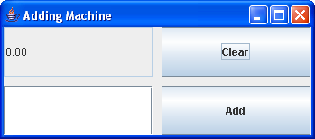

The user can enter a number (in this case 500.25) in the Amount field.

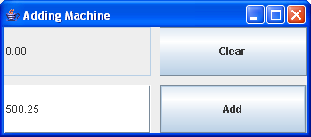

When the user clicks the Add button, the amount in the Amount field is added to the number in the Sum field. The Sum field now displays the new amount.

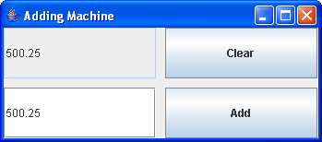

The user can then add a second number to the Amount field (in this case 450.11) and after clicking on the Add button, the Sum field now contains the previous sum and the new Amount (500.25 + 450.11 = 950.25).

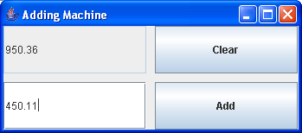

If the user now clicks the Clear button, the Sum field will be reset to “0.00”. Any new number added will start a fresh calculation.

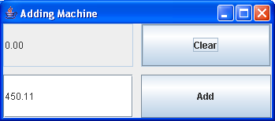

Submission:
Print out the class definitions of all classes and label them as “Part 1”. Be prepared to demonstrate your application in class to your instructor.

Part 2:
The application developed in Part 1 works well but has some problems. For one thing, the user has to use his or her keyboard to type in a number, and then move their hand to the mouse to click the Add button. This takes time and can be tiring if adding large numbers.

To make this application easier for users, make the following changes:
- When a user enters a new number in the Amount field and presses the “Enter” key, perform the add function by adding the value of the Amount field to the Sum field (this means the user can add numbers without the Add key).
- After a number is added, reset the value of the Amount field to an empty string (this way the user doesn’t have to erase the previous number before adding a new one).

For example, the Sum field has 450.11 and the user enters 500.25 in the Amount field.

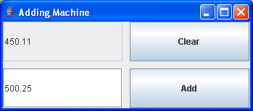

When the user presses the “Enter” key, the Sum field is calculated to contain 450.11+500.25=950.36 and the Amount key is set to an empty field. The user does not have to press the Add button at all.

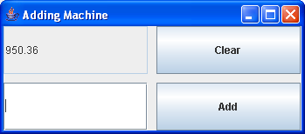

Submission:
Print out the class definitions of all classes and label them as “Part 2”. Be prepared to demonstrate your application in class to your instructor.

Part 3:
There may be times when the user enters a non-numeric value in the Amount field.

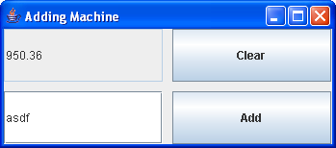

This causes a NumberFormatException to be thrown.

Exception in thread "AWT-EventQueue-0" java.lang.NumberFormatException: For input string: "asdf"
at sun.misc.FloatingDecimal.readJavaFormatString(FloatingDecimal.java:1224)

In cases like this, your application should not try to add the number at all. It should just ignore the input. Hopefully the user will enter the correct number next time. Change your code so that this exception is properly handled.

Submission:
Print out the class definitions of all classes and label them as “Part 3”. Be prepared to demonstrate your application in class to your instructor.

CP1971 Java II – Assignment 5 Grading Grid

Student Name: |  | Student #:

Totals: |  | /100
Part 1: |  | /65
 | Basic GUI Layout | /20
 | ActionHandler inner class | /20
 | Proper event processing | /20
 | Demonstration | /5
Part 2: |  | /20
 | Modification of ActionHandler | /5
 | Modification of Event processing | /10
 | Demonstration | /5
Part 3: |  | /15
 | Error Handling | /10
 | Demonstration | /5

